A project report on

**RESUME SCREENING**

Submitted in partial fulfillment of the requirements for the Degree of

B. Tech in 4th Year

By

**VARSHA JHA**

**GUNJAN BEHERA**

**SHUBHANGI SRIVASTAVA**



**SCHOOL OF COMPUTER ENGINEERING**

**KALINGA INSTITUTE OF INDUSTRIAL TECHNOLOGY**

**DEEMED TO BE UNIVERSITY**

**BHUBANESWAR, ODISHA**

**2021-22**

# CERTIFICATE

This is to certify that the project report entitled “MY MUSIC APP **”**

submitted by

**VARSHA JHA**

**GUNJAN BEHERA**

**SHUBHANGI SRIVASTAV**

in partial fulfillment of the requirements for the award of the **Degree of Bachelor of Technology** in **Discipline of Engineering** is a bonafide record of the work carried out under my(our) guidance and supervision at School of Computer Science Engineering, Kalinga Institute of Industrial Technology, Deemed to be University.

# ACKNOWLEDGEMENTS

We would like to express our special thanks to our project guide Prof. Santwana Sagnika who gave us the golden opportunity to do this wonderful project of Computer Science & Engineering on “Resume Screening”, who also helped us in completing our project. We got to know about so many new things and their implementation in required places.

Secondly,we would also like to thank our parents and friends who helped us a lot in finalizing this project within the limited time frame.

**VARSHA JHA (1805086)**

**GUNJAN BEHERA (1805664)**

**SHUBHANGI SRIVASTAVA (1805706)**

**ABSTRACT**

Technology is the most useful form of science in today’s world. In simple words, technology is when we take the concepts of science and transform them into gadgets and devices that are useful to us as human beings. When we look around us, almost everything is a result of or a form of technology.So to continue creating new device and gadgets we also need the right person with proper knowledge in specific technologies that can be used to develop.

This project aims in choosing the right people for a job is the biggest responsibility of every business since choosing the right set of people can accelerate business growth exponentially.

# TABLE OF CONTENTS

Abstract : 4

Table of Contents : 5

CHAPTER 1: INTRODUCTION : 6

* 1. About the Project
  2. Aim of the Project
  3. Objective of the Project

CHAPTER 2: BACKGROUND/BASIC CONCEPTS

|  |  |
| --- | --- |
| : | 7 |
| : | 7 |
| : | 12 |
| : | 13 |
| : | 14 |
| : | 14 |
| : | 18 |
| : | 21 |
| : | 24 |
| : | 25 |
| : | 26 |
| : | 27 |
| : | 28 |

* 1. Angular Framework
     1. Angular architecture
  2. .Net Framework with C#
  3. SQL Server Database

CHAPTER3: PROJECT ANALYSIS/ PROJECT IMPLEMENTATION

* 1. Angular Framework (Frontend)
  2. SQL Server Database (Backend)
  3. .Net Framework with C# (Backend) CHAPTER 4: RESULTS AND DISCUSSION CHAPTER 5: CONCLUSION & FUTURE WORK REFERENCES

INDIVIDUAL CONTRIBUTION

PROJECT REPORT PLAGIARISM CHECK

**CHAPTER 1**

**INTRODUCTION**

Tells the readers what the report is about, aims and objectives of the project work and how the report is organized into different chapters.

**About the project**

Companies often receive thousands of resumes for each job posting and employ dedicated screening officers to screen qualified candidates.

Hiring the right talent is a challenge for all businesses. This challenge is magnified by the high volume of applicants if the business is labour-intensive, growing, and facing high attrition rates.

IT departments are short of growing markets. In a typical service organization, professionals with a variety of technical skills and business domain expertise are hired and assigned to projects to resolve customer issues. This task of selecting the best talent among many others is known as “ Resume Screening”.

Typically, large companies do not have enough time to open each CV, so they use machine learning algorithms for the Resume Screening task

In this project we will demonstrate how to build a model predicting readmission in Python using the following steps

* data exploration
* feature engineering
* building training/validation/test samples
* model selection
* model evaluation

**Aim of the project**

Resume Screening is the process of determining whether a candidate is qualified for a role based on his or her education ,experience,and information captured on their resume.

**Objective of the project**

After recruitment program,Companies get a 1000’s of resume in their portal.

It becomes very difficult for the hiring teams to read the resume and select the resume according to the requirement, there is no problem if there are one or two resumes but it is very difficult to go through 1000’s resumes and select the best one.

To solve this problem,in this project we will read and screen the resume using machine learning with Python so that we can complete days of work in few minutes.

**CHAPTER 2**

**BACKGROUND**

We have used the following tools & technologies in this project:-

1. Python
2. Deep Learning
3. Machine Learning

**Python**

Python is a computer programming language often used to build websites and software, automate tasks, and conduct data analysis. Python is a general-purpose language, meaning it can be used to create a variety of different programs and isn't specialized for any specific problems.

Python is an interpreted, object-oriented, high-level programming language with dynamic semantics. Its high-level built in data structures, combined with dynamic typing and dynamic binding, make it very attractive for Rapid Application Development, as well as for use as a scripting or glue language to connect existing components together. Python's simple, easy to learn syntax emphasizes readability and therefore reduces the cost of program maintenance. Python supports modules and packages, which encourages program modularity and code reuse. The Python interpreter and the extensive standard library are available in source or binary form without charge for all major platforms, and can be freely distributed.

Often, programmers fall in love with Python because of the increased productivity it provides. Since there is no compilation step, the edit-test-debug cycle is incredibly fast. Debugging Python programs is easy: a bug or bad input will never cause a segmentation fault. Instead, when the interpreter discovers an error, it raises an exception. When the program doesn't catch the exception, the interpreter prints a stack trace. A source level debugger allows inspection of local and global variables, evaluation of arbitrary expressions, setting breakpoints, stepping through the code a line at a time, and so on. The debugger is written in Python itself, testifying to Python's introspective power. On the other hand, often the quickest way to debug a program is to add a few print statements to the source: the fast edit-test-debug cycle makes this simple approach very effective.

**Deep Learning**

Deep learning is a subset of machine learning, which is essentially a neural network with three or more layers. These neural networks attempt to simulate the behavior of the human brain—albeit far from matching its ability—allowing it to “learn” from large amounts of data.

Deep learning is a machine learning technique that teaches computers to do what comes naturally to humans: learn by example. Deep learning is a key technology behind driverless cars, enabling them to recognize a stop sign, or to distinguish a pedestrian from a lamppost.

Deep learning utilizes both structured and unstructured data for training. Practical examples of deep learning are Virtual assistants, vision for driverless cars, money laundering, face recognition and many more.

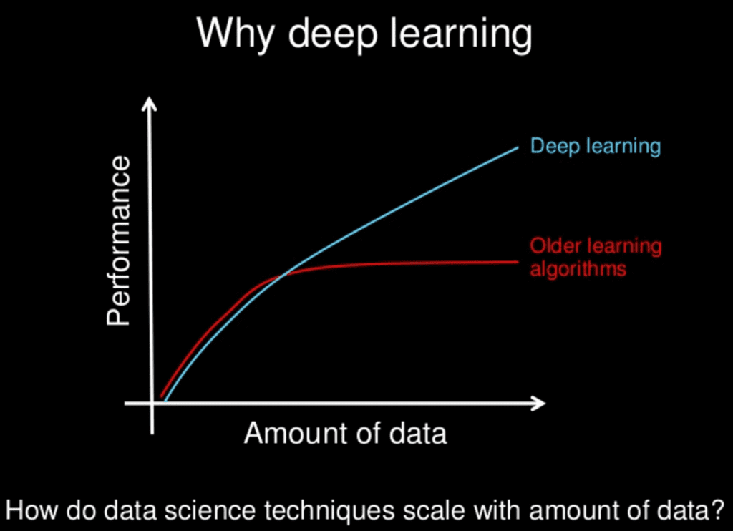

**Machine Learning**

Machine learning is the concept that a computer program can learn and adapt to new data without human intervention. Machine learning is a field of artificial intelligence (AI) that keeps a computer's built-in algorithms current regardless of changes in the worldwide economy.

Today, ML algorithms are trained using three prominent methods. These are three types of machine learning: supervised learning, unsupervised learning, and reinforcement learning.

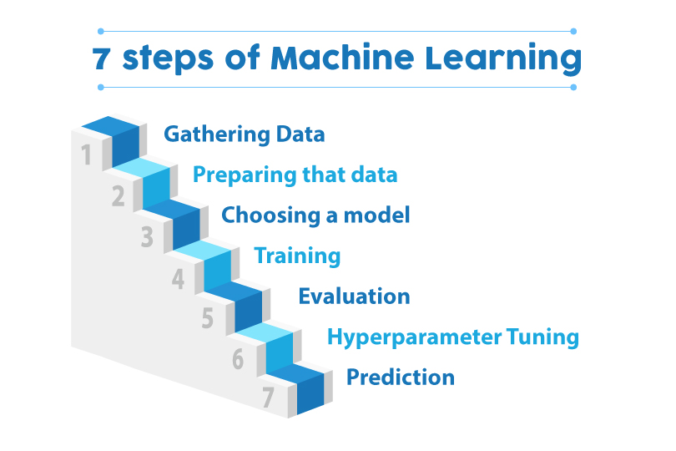

**CHAPTER 3**

**PROJECT ANALYSIS/ PROJECT IMPLEMENTATION**

**CHAPTER 4**

**RESULTS & DISCUSSIONS**

**CHAPTER 5**

**CONCLUSION AND FUTURE WORK**

Till now we have only focused in the backend part of the project .But in future we will are trying to build the forntend and connecting the both frontend and backend using .net and c#.

**REFERENCES**

[https://www.kaggle.com/gauravduttakiit/resume-dataset](https://www.kaggle.com/gauravduttakiit/resume-dataset" \t "https://www.analyticsvidhya.com/blog/2021/06/resume-screening-with-natural-language-processing-in-python/_blank)

